Proiect Nr. 4 – Calcul Integral
Varianta 17

Sarcina 1
∫[1.0,2.6] sqrt(0.4x+3)/(0.7x+sqrt(2x^2+0.5)) dx
x | f(x)
1.000 | 0.808328
1.178 | 0.707337
1.356 | 0.628998
1.533 | 0.566720
1.711 | 0.516152
1.889 | 0.474340
2.067 | 0.439228
2.244 | 0.409343
2.422 | 0.383610
2.600 | 0.361225
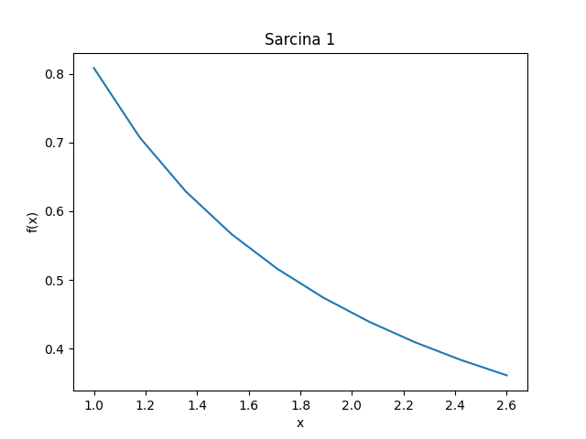

Sarcina 2
∫[0.4,1.8] sin(0.2x^2+0.7)/(1.4+cos(0.5x+0.2)) dx
x | f(x)
0.400 | 0.287954
0.556 | 0.301647
0.711 | 0.319232
0.867 | 0.340620
1.022 | 0.365623
1.178 | 0.393923
1.333 | 0.425020
1.489 | 0.458178
1.644 | 0.492360
1.800 | 0.526157
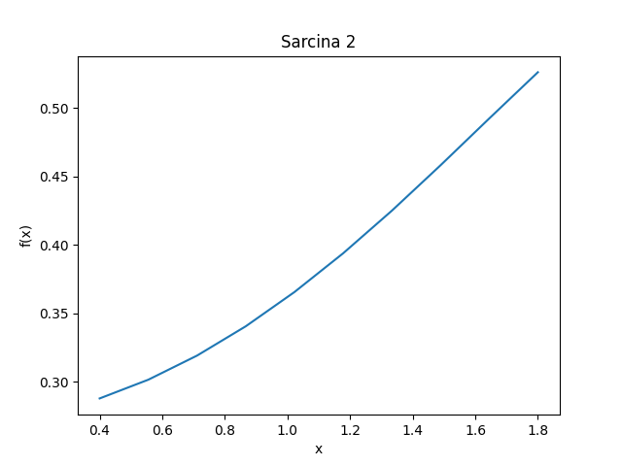

Sarcina 3
∫[0.6,1.6] dx/sqrt(x^2+0.8)
x | f(x)
0.600 | 0.928477
0.711 | 0.875149
0.822 | 0.823094
0.933 | 0.773566
1.044 | 0.727227
1.156 | 0.684336
1.267 | 0.644900
1.378 | 0.608776
1.489 | 0.575741
1.600 | 0.545545
